Study Title: EFFECTS OF LEMON VERBENA EXTRACT SUPPLEMENTATION ON BEHAVIOUR MOOD AND COGNITIVE FUNCTION IN SUB-ADHD CHILDREN

Investigator: Dr Philippa Jackson

Parent/ guardian Information Sheet

Your child is being invited to take part in this research study. Before you decide if they should take part, it is important for you to read this leaflet so you understand why the study is being carried out and what it will involve.

As parent or legally responsible person, you will be required to give your consent to the participation of your child in the research study. Your child will also be required to give their assent to take part.

Reading this leaflet, discussing it with others or asking any questions you might have will help you decide whether or not you would like your child to take part.

What is the Purpose of the Study?
Lemon verbena is a plant native to South America that may be beneficial to human health. For example, previous research has indicated that lemon verbena has sedative and anxiolytic effects.
The aim of the current study is to assess the psychological effects of 8 weeks’ supplementation with lemon verbena extract in children aged 8-17 who are rated by their parents as having ADHD-type behaviour.

Why have I been invited?

Your child has been invited because they meet the following criteria*:
- In good health as reported by themselves and their parent/guardian
- Are aged 8 to 17 years at the time of giving assent and parents giving consent
- Have a sex and age-related BMI less than the 98th centile according to the local NHS guidelines https://www.nhs.uk/live-well/healthy-weight/bmi-calculator/
- Are rated by a parent as having high ADHD type behaviour as assessed by the Conners’ Parent Rating Scale
- Have no current diagnosis of ADHD
- Have no relevant food intolerances/ sensitivities/ allergies
- Are not currently using any illicit, herbal, or recreational drugs including alcohol and nicotine products
- Are not currently taking prescription medications
- Have not taken dietary supplements e.g., Vitamins, omega 3 fish oils etc. in the last 4 weeks
- Do not have a diagnosed neurological condition, or learning/behavioral or neurodevelopmental differences (e.g., dyslexia, autism)
- Do not suffer from visual (including color blindness) impairment that cannot be corrected with glasses or lenses
- Do not have any pre-existing diagnosed medical condition/illness which will impact taking part in the study
- Consume less than 250 mg/day of caffeine.
- Can complete all the study assessments at the training visit
- Are not currently participating in other clinical or nutrition intervention studies, or have in the past 4 weeks
- Are compliant with regards to treatment consumption
- Have not taken antibiotics within the past 4 weeks
- Do not have any health condition that would prevent fulfilment of the study requirements (this includes non-diagnosed conditions for which no medication may be taken)

Does my child have to take part?

No. It is up to you and your child whether you would like them to take part in the study. I am giving you this information sheet to help you make that decision. If you do decide that you are happy for them to take part, remember that you can stop being involved in the study whenever they or you choose, without telling me why. You are completely free to decide whether you would like them to take part, or to take part and then leave the study before completion. (NOTE: We may ask your reason for withdrawal for feedback purposes, but you do not have to tell us. We may also ask if we can use the data, you have provided thus far; again, you do not have to agree to this).

What will happen if I take part?

You will attend the Research Centre (Brain, Performance Nutrition Research Centre within Northumbria University’s City Campus) with your child on 4 separate occasions, and complete one online prescreening questionnaire and one remote screening appointment (approx. 30 mins via telephone call) prior to attending the Centre. Please See Figure 1 for a timeline of all appointments.

You will be sent a link via email to complete an online questionnaire about your child (CPRS:S). If your child meets the criteria for the study based on your response to this questionnaire, you will then undergo a screening appointment via telephone call with one of the researchers to collect demographic information and check your child is eligible with regards to other criteria outlines above, as well as obtaining informed assent (child) and consent (parent/guardian). The introductory/training visit to the Research Centre will begin with physiological eligibility measures that cannot be completed remotely (e.g., height and weight, WHR) followed by training on the cognitive and mood measures. This visit will last approx. 2-3 hours.
Following the introductory/training visit, you and your child will attend the research centre in the morning on three separate occasions. All Research Centre testing visits will take place at the weekend and each of these assessments will be identical, comprising (following the collection of blood pressure and temperature data) the completion of behaviour (CASS:S, VAS) and mood questionnaires and computerised cognitive assessment. Heart rate monitoring will be collected throughout the assessment. Each of the three testing visits to the Research Centre will last approx. 1.5 hours.
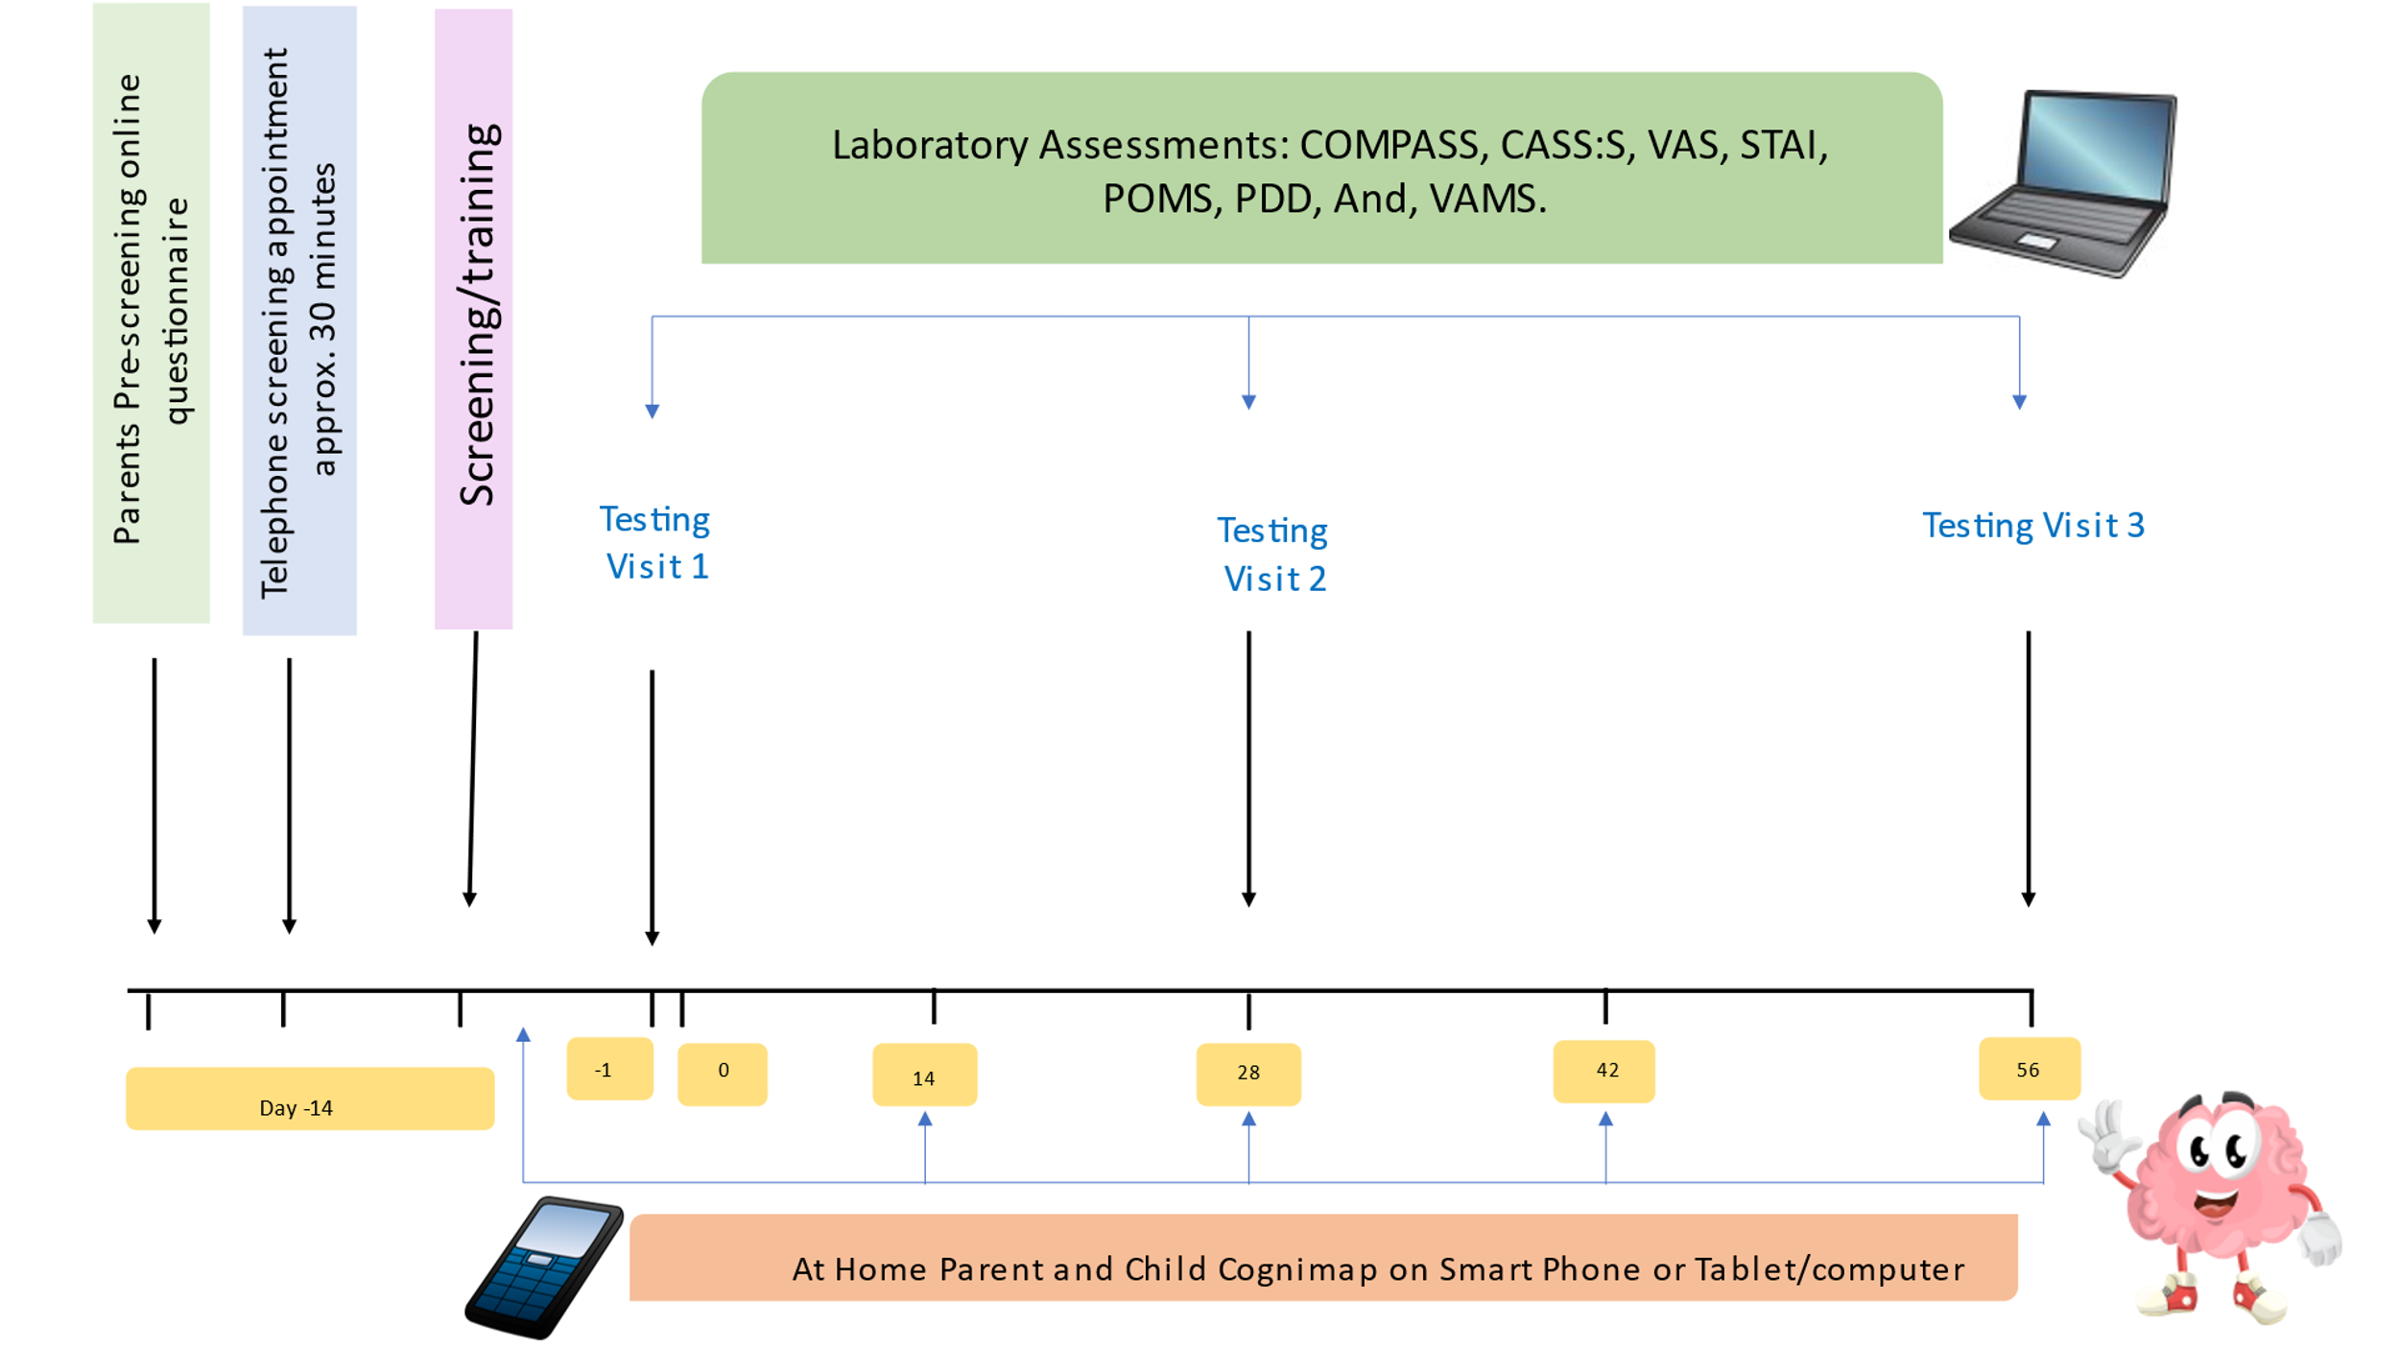
Your child will also be asked to complete some online assessments at home between the testing visits. These assessments will be emailed to you and require a smartphone or tablet/computer to complete. The online assessments will be required to be completed before their first visit and on days 14, 28, 42, and 56 of supplementation. During the days between testing visit 1 and testing visit 3, your child will be required to take the supplements each day whilst at home before breakfast. They will also be required to complete a dosing diary each day with he of consuming the treatment noted.

Figure 1: A timeline of all study appointments, visits, and at home activities.

What are the possible benefits of taking part?

Your child’s participation will hopefully add to the growing body of evidence showing the cognitive and mood benefits of Lemon Verbena.

Your child will be recompensed £120 in vouchers upon completion of the study which is intended to cover your child’s time commitment and any other out-of-pocket expenses you might incur as a result of taking part. You, as the child’s parent/caregiver, will receive £30 upon completion of the study to compensate for travel expenses.

What are the possible disadvantages of taking part?

The study product is a small capsule containing either Lemon Verbena at 15mg/kg or placebo.
Lemon Verbena containing supplements are classified as food or food supplements and are available to purchase within the UK and EU. It is not associated with any significant deleterious side effects.

You may be reluctant for your child to take part in a study assessing their cognitive performance, however, all data provided by your child contains only their participant code (e.g. 672) and not their name. The only instance in which this data would ever be linked to your child would be if you asked us to withdraw their data from the study; here we would have to break your child’s anonymized code in order to destroy their data.

Your child will be required to remain seated a desk for the duration of the cognitive assessments and during any breaks. Prolonged computer testing may cause some minor discomfort and your child may feel tired at times. It is therefore important that the correct eyewear is brought along to testing sessions and you inform the researcher of any back/arm/wrist problems your child may have.

Your child will be required to wear a heart rate monitor and watch at different points during testing whilst in the Research Centre. The equipment will need to be fasted securely but any discomfort from this should be minimal.

Will my child’s participation in this study be kept confidential and anonymous?

Your child’s data will be kept pseudonymized. This means that your child’s data will be anonymized, however, a single copy of a linking document will be retained by the research team at the research center. As noted above, your child’s name will not be written on any of the data we collect; the written information your child provides will have an ID number, not their name. Their name will also never appear in any reports or documents resulting from this study. The only document containing the full names of participants alongside their related anonymized code is the participants identification list and this will be stored in a locked filing cabinet separate from all other forms of data pertaining to this study. The consent form you and your child will sign will be stored separately from your child’s other data. The data collected from you and your child in this study will be kept confidential. The only exception to this confidentiality is if the researcher feels that your child or others may be harmed if information is not shared.

How will my data be stored, and how long will it be stored for?

We will store the data for a minimum of 15 years following completion of this study unless the sponsor of the study or the journal article we publish within requires an extension of this period. Please note that the data retained after the 15-year period will only be anonymized data rather than personally identifiable data. During this 15-year period, all electronic data including the consent forms you and your child provided will be kept on secure password protected computers/servers accessed only by the research team. As before, consent forms will be stored separately from identifiable data. All data will be stored in accordance with University guidelines and GDPR.

What categories of personal data will be collected and processed in this study?

During the screening and training visits (appointment 1 & 2) we will take demographic data including age, sex, height/weight (used to calculate BMI), race, and will ask you to confirm that your child does not meet any of the exclusion criteria. During the testing visits we will collect their cognitive performance/mood data as well as data from the heart rate monitors your child will be wearing during the cognitive assessments and at rest. Performance data will also be collected from the cognimap assessments completed at home by your child in between the in-person visits.

What is the legal basis for processing personal data?

The legal basis for processing the personal data required for the purposes of this study is that the research is necessary for scientific research purposes.

Who are the recipients or categories of recipients of personal data, if any?

Only the research team here at Northumbria University will have access to your personal data. The funder of the study, Finzelberg, or the journal article that we publish the study within may request access to the study data, but this will either contain only your participant code (e.g., 016) or no identifying information at all, never your name, and this will be shared using encrypted passwords or the secure ‘SharePoint’ tool.

What will happen to the results of the study, and could personal data collected be used in future research?

The general findings might be reported in a scientific journal or presented at a research conference; however, the data will be anonymized and your child or the data your child has provided will not be personally identifiable. The findings may also be used in future studies (e.g., when conducting meta-analyses) or shared with other organizations/ institutions that have been involved with the study. We will send a summary of the results to you once the study has completed and the data has been analysed. Please note that this can sometimes be several months after the study has completed. Results will be sent to the email address that you have used to communicate with us throughout the study.

Who is Organizing and Funding the Study?

The study was designed and is being conducted by the research team here at Northumbria University. The funding is provided by Finzelberg for the purposes of testing their investigational product.

Who has reviewed this study?

Before this study could begin, permission was obtained from Northumbria University and this study has received ethical approval from the Northumbria University Psychology Staff Ethics Committee

What are my rights as a participant in this study?

Under the GDPR legislation you have right of access to your child’s personal data (to do so you should submit a Subject Access Request); a right in certain circumstances to have inaccurate personal data rectified; and a right to object to decisions being taken by automated means. If you are dissatisfied with the University’s processing of personal data you have the right to complain to the Information Commissioner’s Office. For more information see the ICO website.

Contact for further information:

Researcher email: hl.lemon.verbena@northumbria.ac.uk

Investigator email: philippa.jackson@northumbria.ac.uk

Name and contact details of the Data Protection Officer at Northumbria
University: Duncan James (dp.officer@northumbria.ac.uk).

