Faculty of Health & Life Sciences

Study Title: The chronic cognitive effects of 6 and 12 weeks administration of a food supplement containing Sharp•PS® green: A double blind, randomized, placebo controlled, parallel groups study in healthy children aged 8 to 12 years

Principle Investigator: Dr Philippa Jackson

Participant Information Sheet
Your child is being invited to take part in this research study. Before you decide if they should take part it is important for you to read this leaflet so you both understand why the study is being carried out and what it will involve. As parent or legally responsible person, you will be required to give your consent to the participation of your child in the research study. Your child will also be required to give their assent to take part.
Reading this leaflet, discussing it with others or asking any questions you might have will help you decide whether or not you would like your child to take part.

What is the Purpose of the Study?
Phosphatidylserine is a nutrient that occurs naturally within the body and is also found in many of the foods we eat. It is important for brain function because it plays an essential role in building the structure of the cells within the brain and is required for efficient communication throughout the nervous system. There is some research to suggest that increased ingestion of phosphatidylserine can improve cognitive function and memory in adults and in children. The aim of this study is to investigate whether taking a phosphatidylserine-containing supplement (gummies) daily for 12 weeks can improve brain functioning (attention, learning and memory) and mood in healthy children aged 8 to 12 years (school years 4 to 7).

Why have I been invited?
Your child has been invited because they meet the following criteria*:
- In good health as reported by themselves and their parent/guardian.
- Healthy children aged 8 to 12 years and enrolled in school years 4 to 7 at the time of giving consent.
- Have been speaking English at school since Reception.
- Have a sex and age-related BMI according to the local NHS guidelines within the 3rd to 97th percentiles. https://www.nhs.uk/live-well/healthy-weight/bmi-calculator/

Your child is not eligible to take part in this trial if they:
- Fall into the ‘high’ or ‘moderate’ risk categories from coronavirus as defined by NHS UK
- Have an allergy or known hypersensitivity to one of the following ingredients: Phosphatidylserine and other lipids from sunflower lecithin, maltodextrin, silicon dioxide, antioxidants (mixed tocopherols and ascorbyl palmitate), sulphur dioxide, sulfite, sulphate, glucose syrup (contains sulfite), sugar, citric acid, pectin, trisodium citrate, flavors, color (black carrot concentrate), soybeans and products thereof, fish and products thereof, crustaceans and products thereof.
The gummies contain the following allergens: Sulfite, sulphate and sulphur dioxide
The gummies may come in contact with the following allergens: soybeans and products thereof, fish and products thereof, crustaceans and products thereof.
- Are currently taking any illicit, herbal or recreational drugs including alcohol and tobacco.
- Have used dietary supplements within the last 4 weeks (for example: vitamins, minerals, and specialty products including omega-3 fatty acid, probiotics, prebiotics, phosphatidylserine, antioxidants, etc.).
- Are diagnosed with ADHD, dyslexia or any neurodevelopmental disorder or learning difficulty.
- Suffer from visual (including colour blindness) or hearing impairment that may impact task performance.
- Have any serious illness, cognitive impairment or medical disorder that may confound with study results or interfere with compliance.
- Have any other active or unstable medical condition, that, in the opinion of the PI, may adversely affect the participant's ability to complete the study. Unfortunately, asthma is an exclusion in this study.
- Are experiencing exceptional social/family stressors.
- Taking any prescribed or OTC medication used to treat chronic or non-chronic illnesses.
- Consume more than one portion (>100g) per week of the following dietary sources high in phosphatidylserine: Oily fish such as salmon, mackerel, herring, tuna and eel. Animal internal organs such as liver, kidney, brain and heart.
- Have followed a specific diet, e.g. high protein diet, within 30 days prior to study start
- Have had a serious diet change, e.g. Ketogenic or vegan, within 30 days prior to study start.
- Consume more than 250 mg/day of caffeine.
- Are unable to complete all of the study assessments
- Are currently participating in other clinical or nutrition intervention studies, or have done so in the past 8 weeks
- Will be non-compliant with regards to the study’s treatment consumption

Please check with the research team if there is anything you are unsure of.
* Please note that this study utilizes the listed criteria for methodological reasons and marketing purposes related to the investigational product. All criteria have been fully considered and have a sound rationale. Whilst it would be too lengthy to include the rationale behind the inclusion/exclusion criteria here, these are available on request by emailing the study principle investigator; philippa.jackson@northumbria.ac.uk

Does my child have to take part?

No. It is up to you and your child whether you would like them to take part in the study. We are giving you this information sheet to help you make that decision. If you do decide that you are happy for them to take part, remember that they can stop being involved in the study whenever they or you choose, without telling us why. They and you are completely free to decide whether or not to take part, or to take part and then leave the study before completion.
(NOTE: We may ask your reason for withdrawal for feedback purposes, but you do not have to tell us. We may also ask if we can use the data you have provided thus far; again, you do not have to agree to this).

What will happen if my child takes part?
You will attend the laboratory (Brain, Performance Nutrition Research Centre within Northumbria University’s City Campus) with your child on 4 separate occasions and complete one remote screening session prior to the 4 lab visits.
The first appointment is the remote screening session completed via video/telephone call with the research team at a pre-arranged time where both you and your child can be present e.g. in the afternoon (after school) or on weekends. If using video call, you do not need to download any special software to complete this session, the research team will send you a link which you will need to click at the arranged time to start the call. This session will comprise briefing on requirements of the study, obtaining of informed consent from you and assent from your child via an online form, health screening (self-reporting on your child’s behalf) and collecting demographic data (age, sex, eligibility for free school meals, parental occupation/income etc). You will also be asked at this visit if your child would be willing to be part of an optional sleep monitoring subgroup (only 60 participants will be able to be included in this subgroup and spaces will be allocated on a first-come-first-served basis). The screening appointment will last approximately 30-45 mins.
The second appointment will be the first visit to the lab (training appointment) and will last approximately 2 hours. On arrival, we will take eligibility measurements that we were unable to do during appointment 1 (height and weight to calculate BMI) and, provided these readings are within our required range, we will give your child the chance to practice the cognitive tasks that will be used within the study (which include tasks assessing learning, memory, attention and mood). NOTE: Some eligibility assessments such as height and weight to calculate BMI can only be done in person. Please be aware it is possible that if your child’s measurements are out of the required range for this study this will not be known until appointment 2 and your child will not be able to continue with the study. We apologise for any inconvenience or disappointment should this happen. You will also be given a questionnaire for your child to take home to complete before their next visit (see Appointment 3 info for details). If your child has opted into the sleep element of the study, they will be given an ActiGraph sleep watch that should be worn (on their non-dominant wrist) for the 7 days prior to their next visit. The device must be worn continuously throughout this period except when bathing. A sleep diary will also be provided and should be completed every day noting bedtime and wake time. This procedure will be repeated in the 7 days prior to the final appointment; therefore, you will be required to come in for an extra, short appointment at least 7 days prior to the final visit to collect the sleep watch and diary. Sleep watches and diaries should be brought in with you to the appointment following each sleep-monitoring period.

This appointment will be followed within 1-28 days by the third appointment, which is the first testing visit. If more than 28 days elapse between training and the third appointment, then your child will be invited to return for a ‘refresher’ training visit before commencing the study. The third appointment will take place at a pre-arranged time in the morning at weekends. Please see Figure 1 for a timeline of testing sessions.

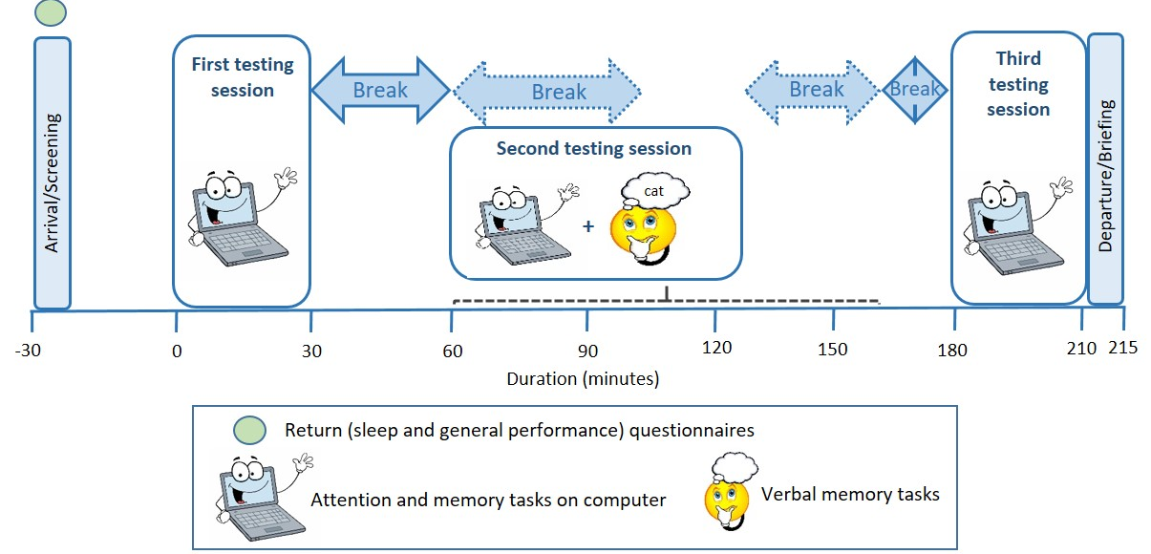
Figure 1: Timeline of testing sessions
Your child should avoid all caffeine containing food and beverages from waking until the end of the testing visit. Some examples include chocolate, hot chocolate, chocolate cereals, chocolate milk, chocolate spread, cola, tea and coffee. Please also avoid all sugary soft drinks (either caffeine containing or not). Your child will attend the laboratory having consumed breakfast (of cereal and/ or toast, to be replicated prior to each testing visit) at home no later than one hour prior to attendance. Please note, your child will not be able to consume anything other than water until the end of the testing visit (at approximately 12.30pm) once they have finished their breakfast at home. Prior to attending you will be asked to confirm via an online form that your child continues to meet the inclusion and none of the exclusion criteria. Upon arrival you and your child will answer some brief screening questions and you will return completed/confirm completion of three different questionnaires. The Sleep Self Report is a paper questionnaire completed by your child asking about their sleep habits. The Children’s Sleep Habits questionnaire is an online questionnaire completed by you, their parent/guardian, asking questions about your child’s sleeping habits and the Parent Visual Analogue Scales are completed online and ask you about your child’s general performance. Your child will then commence the first cognitive testing assessment (lasting approximately 30 minutes). This will be followed after a short break (approximately 30 minutes), by the second cognitive testing assessment which will be slightly longer (1 hour and 10 minutes) and include two additional tasks assessing memory. A final completion of the cognitive testing assessment (approximately 30 minutes) will commence after another short break (approximately 50 minutes). The first and the last testing assessments are identical and include a range of computerized memory and attention tasks. The second assessment includes many of the same tasks (with an additional computerized memory task) and also a verbal memory task.

During the breaks, your child is permitted to watch TV (on their own device with headphones) or read a book or magazine but is not permitted to play on computer/video games. Note all electronic devices brought into the research centre are the child’s responsibility. The research team will not be monitoring what websites the children visit so it is your responsibility to set up parental controls. Physical activity also should be kept to a minimum. Due to COVID-19 we need to control the flow of people in the lab and, therefore, need to know in advance how many parents intend to stay in the research centre during the testing visit so please let us know. It is not compulsory to stay in the centre but if you decide not to, we ask that you remain in the nearby area (town) and provide contact information for yourself should we need to reach you. Once all assessments are completed, you will return to collect your child and will be provided with the treatment your child will be required to take for the next 42 days (6 weeks) (either active treatment or a matched placebo – 2 x gummies in the morning with food). Forty-two and eighty-four days later you and your child will return to the lab for two further appointments (appointments 4 and 5), which will be identical to the 3rd appointment, with the exception that prior to the Day 42 and Day 84 visits your child will be required to take their allocated treatment at home before testing commences. On day 42 you will also receive a further supply of study treatment for your child to take between days 43 and 84 (2 x gummies in the morning with food). Please see figure 2 for a timeline of study visits.
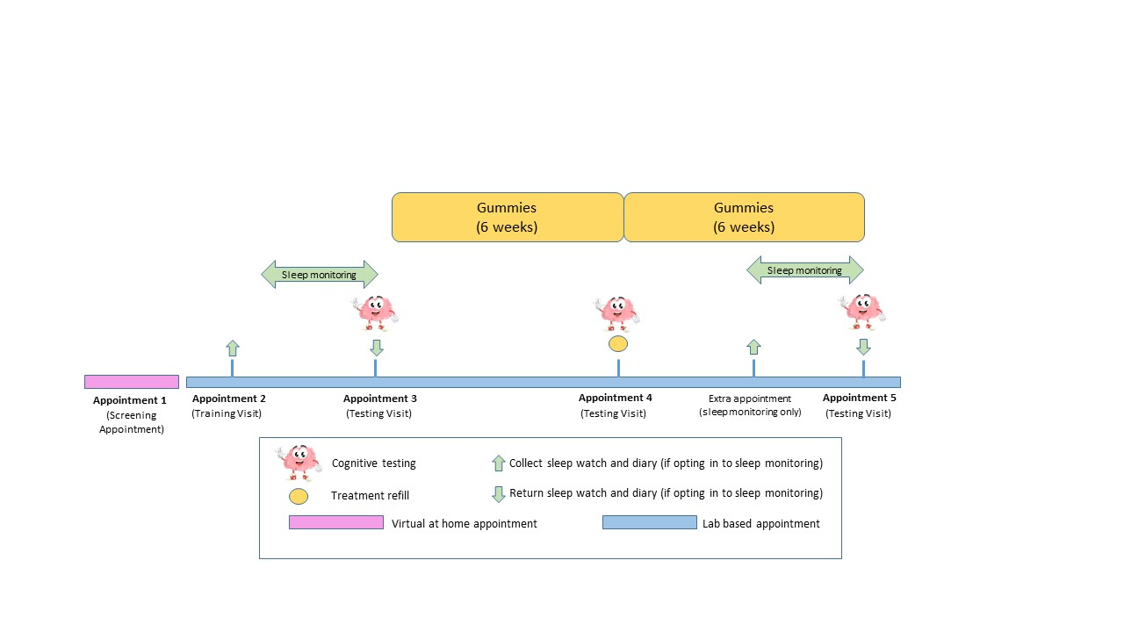
Figure 2: Timeline of testing visits: Note timings given here and in the text are approximates for illustrative purposes and may be subject to change due to implementation of COVID-19 safety measures and unexpected delays.
After your child’s final testing session, you and your child will be debriefed and your child will receive £140 in vouchers for their time in a sealed envelope (participants opting in to the sleep monitoring element of the study will receive an additional £40 in vouchers). Should your child not go on to complete the study in its entirety, they will receive a proportion of the vouchers as recompense for their time.

What are the possible disadvantages of taking part?
The study product Sharp•PS® Green consists of chewable grape flavour ‘gummies’ containing phosphatidylserine. Phosphatidylserine containing supplements are classified as a food or food supplements and are available to purchase within the EU as such. There are no known side effects of taking phosphatidylserine. In this study your child will be asked to take 2 gummies per day which equates to approximately 100mg of phosphatidylserine.

You may feel reluctant for your child to take part in a study assessing their cognitive performance, however, all data your child provides contains only their participant code (e.g. 516) and not their name. This data would only ever be linked to your child if you asked us to withdraw their data from the study; here we would have to break your child’s anonymized code in order to destroy their data.
Your child will be required to remain seated at a desk for the duration of the cognitive assessments and during the breaks. Prolonged computer testing may cause some minor discomfort and your child may feel tired at times. It is therefore important that the correct eyewear is brought along to the testing session and that you inform the researcher of any back/arm/wrist problems your child may have.
All of the research team have received DBS clearance prior to beginning work with your child.

How will my child’s participation experience be impacted by COVID-19 and what measures are in place to protect myself, my child and others?
The COVID-19 pandemic has caused severe disruption to all functions of the University including our research department. The health, safety and wellbeing of our participants and staff has to be the highest priority and we are confident that we have the appropriate measures in place to mitigate risk of transmission so that the risk of contracting or spreading the virus is no greater than that in your/ your child’s day-to-day life.

The University now has a policy where all University staff and students will complete a return to work induction in order to help keep themselves and visitors safe; no staff or students are permitted to return to work without completing this induction. We can confirm that all members of our research team have successfully completed this induction prior to returning to work. All members of the research team on campus will undergo regular lateral flow testing for COVID-19 in accordance with University policy.

More specifically, the University has adopted a new system regarding face-to-face research. In order to resume/start research projects, researchers must now apply for permission to do so explaining why the research must be conducted in person and how the safety of participants and the research team will be assured with risk assessments in place to demonstrate this. Each application is scrutinized by a committee of University executives and the Health and Safety team and no research may be conducted until approval has been granted. We can confirm that this study has been approved by this committee and is deemed safe to conduct with the following measures in place (please go through these measures with your child prior to attendance):

- Wherever possible we will move research activities to be completed remotely e.g. online /telephone screening to minimise the amount of time participation will require you/your child to be on campus. However, due to the nature of our data collection methods this will not be possible for all elements of the study including computerised cognitive testing visits. If you, your child or anyone in your household do feel unwell or experience symptoms of COVID-19 please do not attend the research centre. NOTE: Some eligibility assessments (e.g. height and weight to calculate BMI) can only be done in person. Please be aware it is possible that if your child’s measurements are out of the required range for this study this will not be known until appointment 2 and they would not be able to continue with the study. We apologise for any inconvenience or disappointment should this happen.
- We will now operate with fewer participants attending the lab per day with dedicated days/weeks for testing and training. With this in mind, please be aware availability for bookings is limited and that it may not be possible for us to be as flexible with rescheduling as we have been in the past. Please do not sign your child up to a study or visit if you are unsure if you/they can attend. If something crops up urgently meaning that you need a visit to be
rescheduled, we will do our best to accommodate you but please note this may not always be possible and may result in delayed attendance and even withdrawal from the study.

- Participants are encouraged to choose, where possible, the safest way to travel to Campus. Free parking is already available to participants when pre-booked (24 hours notice required) and you will be encouraged to make use of this where possible (please contact the research team with your registration details in order to request a space). Government guidance on walking, cycling, travelling in private vehicles and on public transport can be accessed here
- At the time of writing, the current government guidance is that everyone must maintain social distancing and that adults and children of certain ages must wear face coverings in enclosed public places. You will find instructions for social distancing and face coverings at the entrance to all university buildings. Please follow this guidance at all times and ensure that you attend each visit with a face covering available. Please also inform your child of the importance of following social distancing and ensure (if of an age required to wear face coverings in public) that they also attend with a face covering available. As this study is recruiting children aged 8-12 there will be a mixture of some children wearing face coverings and others who are not. Please explain to them the reason for this and to be respectful of each other’s differing circumstances and, if required, to comply with wearing face coverings where requested.
- We now require research staff and participants to wear a type IIR (disposable surgical) face mask whenever we are testing including when seated 2m away from each other in the lab. On arrival to the research centre you will be required to change to a type IIR face mask which we will provide. Research staff will wear face masks and in some cases visors where close up contact is required e.g. taking height and weight measures. Parents and children (of an age required to wear face coverings) will also be asked to wear an IIR face mask for these activities. Staff and participants will work side-to-side or back-to-back wherever possible. If you or your child (if of the age required to wear face coverings) are exempt from wearing a face covering please inform the research team ASAP. In this instance we will source you a disposable visor.
- You and your child will be allocated an arrival time and we request you stick to this time as much as possible. If you find that there is a queue outside of (or within) the research centre, please observe social distancing by following the markings on the floor (keeping left). If you are going to be late please call the lab on 0191 243 7252 to check that it is still OK for you to attend. As before, we will do our best to accommodate you but please note this may not always be possible and may result in delayed attendance or even withdrawal from the study.
- Prior to arrival to the unit you will be emailed and required to complete questions to confirm that you and your child (and any members of your household) do not currently have symptoms of COVID-19.
- Universities, along with a number of venues, are required by law to use the NHS Test and Trace system in addition to any manual process we may also have in place for those who don’t have a smartphone. Particularly venues within our university that are open to the public are required to collect details of customers, visitors and staff and display an official QR code poster to strengthen our Covid-19 safety measures on campus. We have an NHS Test and Trace QR within our research centre on the 4th floor. Please scan the QR code using the NHS COVID-19 app when you arrive within the research centre. You can download the app from the Apple app store or Google Play.
- There is an obligation from a track and trace perspective to ensure that any visitors including research participants that attend the University notify us if they have tested positive for Covid-19 within 72hrs of being on campus so that we can carry out any follow up action. In this instance please notify us as soon as possible. We are then required to log the case onto our centralised university COVID-19 notification system. In line with the privacy notice, this data would be held for 21 days before being destroyed. If would like more information about how your data would be processed and stored, this can be found at: https://northumbria-cdn.azureedge.net/-/media/corporate-website/new-sitecore-gallery/services/legal/gdpr/pdf/privnot/2020testandtrace.pdf?modified=20200806132205

- Alcohol gel will be provided at entry and exit points to the University and throughout the campus including the research centre; please use and ask your child to use at regular intervals and before and after handling equipment including your child’s designated testing laptop.
- During your visit, avoid touching your eyes, nose, mouth with unwashed hands, cover your cough or sneeze with a tissue, and throw it away in a bin and wash/gel your hands. Please inform your child of the need to comply with this also.
- We will now be operating a one-way system in and out of Northumberland Building. You will be required to enter Northumberland Building via the Digital Commons entrance (the entrance where the lifts are) from the Quad (the Quad is where the library, Habita and the Students Union are located). When testing is finished, we will ask you to leave via our fire exit.
- Due to COVID-19 we need to control the flow of people in the lab and, therefore, need to know in advance how many parents intend to stay in the research centre during a testing visit so please let us know. If you decide not to, we ask that you remain in the nearby area (city centre) and provide contact information for yourself should we need to reach you. It is important that you discuss this with your child to make sure they will be comfortable with you leaving. If you have any concerns, then please contact the research team to discuss. Please note that during the training session we ask that the parent/guardian accompanying the child remains in the research centre for the duration of the session.
- If you find yourself in a meet-meet situation in a corridor where social distancing cannot be adhered to please keep left and follow floor markings. You might see one-way systems and directional signage across the University campus to guide visitors safely around the site. Please take note of these signs and all other signage, e.g. handwashing advice, and adhere to them across campus. Please inform your child of the need to comply with this also.
- Lift use should be avoided where possible or visitors should use the lifts one by one if essential. If used please give priority to those who need to use a lift, follow the revised maximum occupancy as displayed outside the lift and maintain social distancing, adhering to floor markings where appropriate
- Using the toilet: Social distancing should be maintained in the corridor whilst waiting. Guidance to be displayed on poster outside the toilet. Anyone waiting to use a toilet cubicle or sink must ensure social distancing and stand at least 1 m back to allow the previous occupant space to leave. Please inform your child of the need to comply with this also.
- During study day breaks participants will be required to remain in their testing lab where distancing can be maintained until the next assessment start time. With this in mind we request that participants bring in their own bottled water as access to the water coolers is currently prohibited. We also strongly advise that your child brings a book, magazine or tablet (for watching TV etc., not for games as this might interfere with the study tasks; with headphones if using an app with audio) to pass the time during these breaks. Note participants must take responsibility for the security of their items and they must take all items brought in home with them. Please also note BPNRC staff will not be monitoring the content participants are accessing on their electronic devices and it is the responsibility of the parents to set up parental controls on these devices and to discuss with their child ahead of time what content is or is not suitable for them to access/watch.
- We also ask that participants bring their own pens to all sessions to complete study paperwork and take them with them upon leaving. If you forget we will issue your child with a pen, but this must be returned to us at the end of testing for sterilising
- Participants will be seated in testing labs with a 2-metre gap between them. You are asked to encourage your child to observe social distancing guidelines and keep physical interaction with others to a minimum even if they are attending the same session as a friend or relative.
- All surfaces and door handles will be cleaned frequently with desks cleaned by staff after each use.
- Fire procedures remain unchanged (the researcher will direct your child to their nearest assembly point where they should remain until told by Fire Marshalls/Security that it is safe to re-enter the building), but social distancing must be observed when leaving the building and when congregating in the assembly points.

- We appreciate that these are uncertain times and that participating in our research may add to stress or anxiety you or your child are already experiencing as a result of the COVID-19 pandemic and the difficulties it has caused. Please be assured that their participation is, and always has and always will be, completely voluntary. They can withdraw from the study at any time, even if it is in the middle if a testing session, and do not have to give a reason why
(although we may ask why for feedback, but you/they do not have to give an answer).
The health, safety and wellbeing of our participants is of our highest priority and we understand should you decide to withdraw your/their interest.

For more information and guidance here are links to some of the University’s COVID-19 policies and wider government advice:
Northumbria’s COVID 19 pages
https://www.gov.uk/coronavirus
The Government review of the 2 metre rule

Working safely during COVID in offices
Working safely during COVID in labs and research facilities
PHE quick guides for correct donning and doffing of PPE for non-Aerosol generated procedures (AGPs) as well as for AGPs.
Government advice on face coverings found here
Should you or your child have any queries or concerns please contact your lead researcher who will be happy to discuss any queries or restrictions with you.
We thank you in advance for your patience and compliance with the above.

What are the possible benefits of taking part?

Your child’s participation will hopefully add to the growing amount of evidence showing that phosphatidylserine (a food component that is also synthesized endogenously in the body) is able to boost brain function.

Will my child’s participation in this study be kept confidential and anonymous?

Yes, as noted above, your child’s name will not be written on any of the data we collect; the written information you/your child provides will have an ID number, not their name. Their name will also never appear in any reports or documents resulting from this study. Regarding anonymization, the only document containing the full names of participants alongside their related anonymised code is the participant identification list and this will be stored in a locked filing cabinet separate from all other forms of data pertaining to this study. The consent form you and your child have signed will be stored separately from your child’s other data. The data collected from you/your child in this study will be confidential. The only exception to this confidentiality is if the researcher feels that your child or others may be harmed if information is not shared.

How will the data be stored?

We will store the data for a minimum of 15 years following completion of this study unless the sponsor of the study or the journal article we publish within requires an extension of this period. Please note that the data retained after the 15-year period will only be anonymized data rather than personally identifiable data.
During this 15-year period, all electronic data including the consent forms you and your child provided will be kept on secure password protected computers/servers accessed only by the research team. As before, consent forms will be stored separately from identifiable data. All data will be stored in accordance with University guidelines and GDPR.

What categories of personal data will be collected and processed in this study?
During the screening and training visits (appointment 1 & 2) we will take demographic data including age, sex, height/weight (used to calculate BMI), race, eligibility for free school meals, parental occupation and income and will ask you to confirm that your child does not meet any of the exclusion criteria. During the testing visits (appointments 3-5) we will collect their cognitive performance/mood data as well as data on sleeping habits. For those opting into the sleep part of the study, we will be collecting data about their activity patterns in order to interpret their sleep and wakefulness patterns.

What is the legal basis for processing personal data?
The legal basis for processing the personal data required for the purposes of this study is that the research is necessary for scientific research purposes.

Who are the recipients or categories of recipients of personal data, if any?
Only the research team here at Northumbria University will have access to your child’s personal data. The funder of the study, Frutarom, or the journal article that we publish the study within may request access to the study data but this will either contain only their participant code (e.g. 516) or no identifying information at all, never their name, and this will be shared using encrypted passwords or the secure ‘SharePoint’ tool.

What will happen to the results of the study and could personal data collected be used in future research?
The general findings might be reported in a scientific journal or presented at a research conference; however, the data will be anonymized, and your child’s data will not be personally identifiable. The findings may also be used in future studies (e.g. when conducting meta-analyses) or shared with other organizations/ institutions that have been involved with the study. We can provide you with a summary of the findings from the study if you email the research team at the address listed on page 11.

Who is Organizing and Funding the Study?
The study was designed and is being conducted by the research team here at Northumbria University. The funding is provided by Frutarom for the purposes of testing their investigational product.

Who has reviewed this study?
Before this study could begin, permission was obtained from Northumbria University and this study has received ethical approval from the Northumbria University Psychology Staff Ethics Committee, reference 23091.

What are my rights as a participant in this study?
Under the GDPR legislation you have right of access to your child’s personal data (to do so you should submit a Subject Access Request); a right in certain circumstances to have inaccurate personal data rectified; and a right to object to decisions being taken by automated means. If you are dissatisfied with the University’s processing of personal data, you have the right to complain to the Information Commissioner’s Office. For more information see the ICO website.

Contact for further information:

Researcher email: hl.gummiesstudy@northumbria.ac.uk

Name and contact details of the Data Protection Officer at Northumbria University: Duncan James (dp.officer@northumbria.ac.uk).

